Design Document

Ware House Management System using Finite State Modeling

Introduction
A Finite State Machine (FSM) is defined as program that consists of different states where a number of different transaction can be performed depending on which state the program is currently in. In the literature on automata theory there are two different formulations for FSMs. One is Mealy machine where the output depends on the event and the current state and another is a Moore machine where the output depends only on the state. We will be using concept of Moore machine to develop Warehouse Management System. In our Warehouse Management System different panels will represents the different state of Moore machine. Each Panel is allocated for a person uniquely associated with warehouse to perform their task in warehouse management system. for example Clients uses Client panel, Manager Uses Manage panel and SalesPerson Uses Sales person panel.

Warehouse Management System is a program which is developed to operate the day-to-day activities that occurs in a warehouse. The following are the activities that are performed by the Warehouse Management System.
- Keep a record of all clients of the warehouse
- Keep a record of all the products in warehouse
- Place an odor on products for a client, generate invoice for the odor and accept payment from the client.
- Put product in a wait list when the odor cannot be fulfilled in situations when a product is not available in the inventory
- Update inventory when warehouse revives shipment of products
- Fulfill the odors of clients that were waitlisted.

State transition diagram
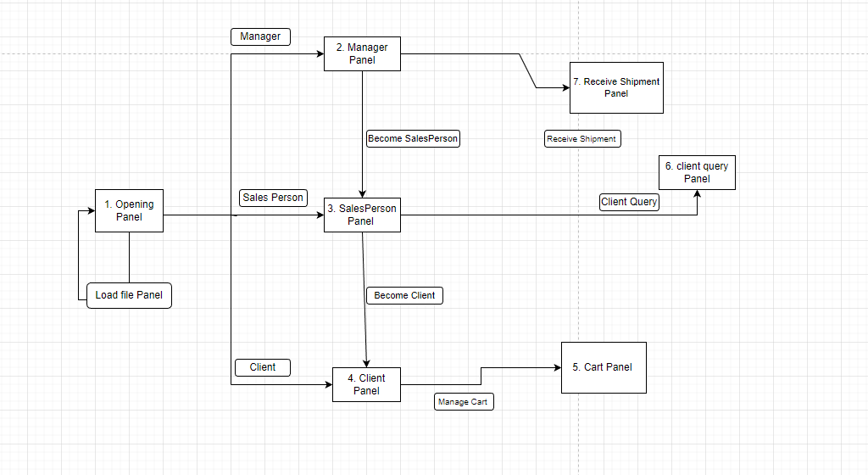

Class Diagram
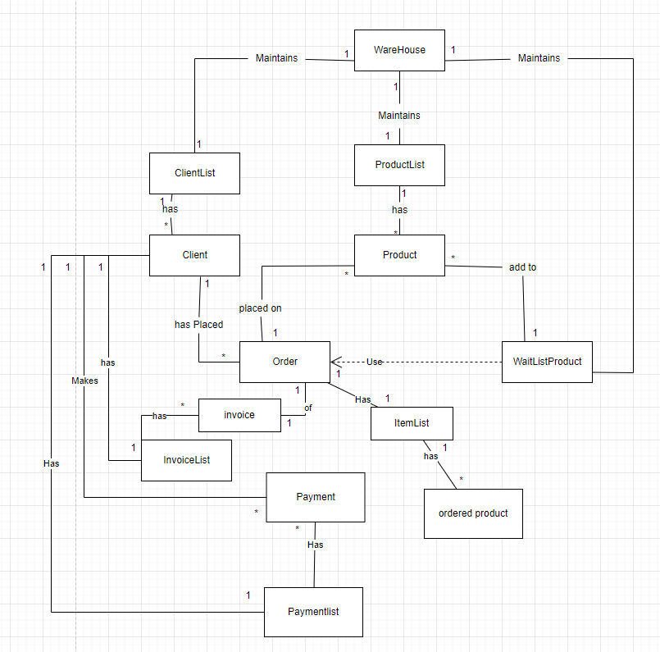

Data Structures

1. Individual client record are stored in client object of client class
2. Individual product record are stored in product object of product class
3. Individual OrderedProducts are stored in OrderedProduct object of OrderedProduct class
4. Individual Order record are stored in Order object of Order class
5. Individual Invoice of an order are stored in invoice object of invoice class
6. Individual Payment record made by a client are stored in Payment object of Payment class
7. Individual Ordered product record are stored in Orderedproduct object of Orderedproduct class
8. Individual Waitlist product record are stored in Waitlistproduct object of Waitlistproduct class
9. ArrayList< client > , ArrayList< product > , ArrayList< OrderedProduct > , ArrayList< Order > , ArrayList< invoice > , ArrayList< Payment > , ArrayList <Orderedproduct > , and ArrayList< Waitlistproduct > inside client class, product class, itemList class, OrderList class, invoiceList class, Payment List class, itemList class, and product respectively records of the Object inside < > bracket of Arraylists.

Implementation of panels
- Opening panel
LoadMenu class consist of main method what creates the object for warehouse class. Once the warehouse Class object is created. All the data structure that consists of list is initialized. LoadMenu then called the constructure of Opening menu to open opening panel. Warehouse object is passes as a parameter to the constructure to share warehouse data between the panels. Opening menu panel consist of in ManagerMenu, Clark menu and ClientMenu, where user has an option to select ether options. ManagerMenu selection calls the Constructor in ManagerMenu passing warehouse object. This opens Manager panel. Clark menu selection calls the Constructor in ClarkMenu pasing warehouse object. This opens salesperson Panel. ClientMenu Selection calls the Constructor in ClieentMenu passing warehouse object. This opens client panel.
- Manager panel
Once the Manager panel is opened data field of warehouse object in ManagerMenu is initialized with warehouse object that was passed as parameter while calling managermenu’s constructor. Manager panel consists of options to add new product in the warehouse system, update the inventory of existing product in the warehouse once the shipment is received, and an option to switch to SalesPerson Panel. To Switch to sales person Panel constructure of Clark menu is called and warehouse data is passed as parameter.
- Sales person panel
Once the Sales Person panel is opened data field of warehouse object in Clarkmenu is initialized with warehouse object that was passed as parameter while calling clarkmenu’s constructor. Sales person panel consists of option to add a new clients to the warehouse system, display the list of product, Open Client Query Panel, accept Payment from a client, Open Client panel and display all the product that are waitlisted. To open Client Query Panel constructure for ClientqueryMenu is called passing Warehouse object as parameter. To open Client Panel user selects a client from a list of client. Then the constructure of ClientMenu is called passing Warehouse and selected Client object as parameter.
- Client panel
Once the client panel is opened data field of client object and warehouse object in client menu is initialized with client object and warehouse object that were passed as parameter while calling clientmenu’s constructor. Client panel contain an option to display the detail of client, display the list of product in the warehouse system, show all the transaction of client, open cart panel, display client wait listed products. To open cart panel client constructure of clientshoppingMenu is called passing warehouse and client object.
- cart panel
Once the cart panel is opened data field of client object and warehouse object in clientShoppingmenu is initialized with client object and warehouse object that were passed as parameter while calling clientShoppingmenu’s constructor. In this panel number of operation are available to modify clients chopping cart.

- receive shipment panel
receive shipment panel is opened by calling processshipment() method in Managermenu. In this panel operation to update inventory and fulfilling waitlisted order after receiving shipment is performed.
- Client Query Panel
Once the Client Query panel is opened data field of warehouse object in clientquerymenu class is initialized with warehouse object that were passed as parameter while calling clientquerymenu‘s constructor. In this panel options can be selected to perform operation to display the entire list of client in the warehouse system, operation to display the list of client with outstanding balance and operation to display the list of client that doesn’t have any transaction in past 6 month.

